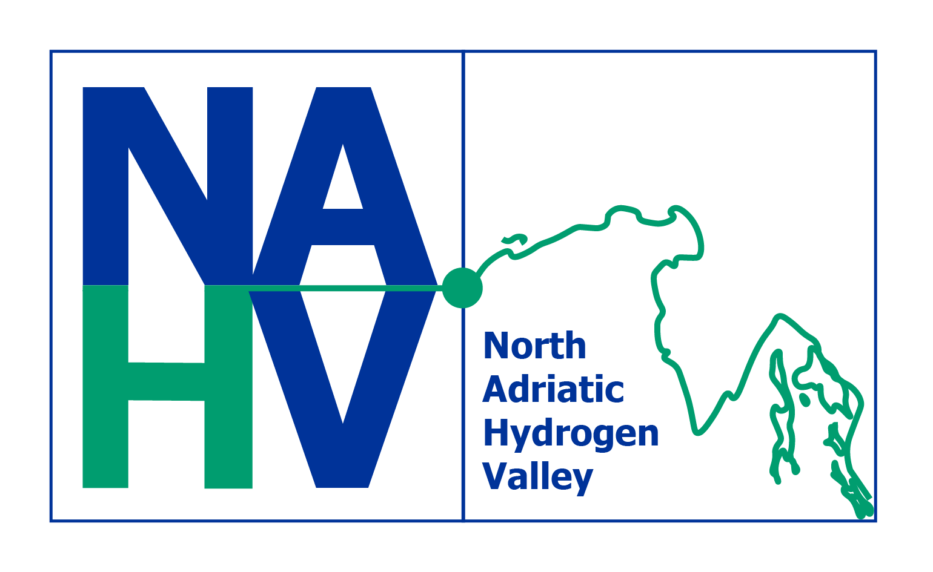

# CONSORTIUM MEETING

## North Adriatic Hydrogen Valley

### Rijeka, 23rd - 24th September 2024

#### Location:

**UNIRI Campus, Hall 003**

**Faculty of civil engineering, University of Rijeka**

**Ul. Radmile Matejčić 3, 51000, Rijeka, Croatia**

## DRAFT AGENDA

#### DAY 1

|  |  |  |
| --- | --- | --- |
| 9:00-9.45 | Registration and morning coffee |  |
| 9:45-10:10 | Welcome  Introduction to the programme  Organisational guidelines for the meeting | **Representative of UNIRI,** Consortium meeting host  **Jerneja, Sedlar**, coordinator, NAHV |
| 10:10-10:25 | **Introductory address of High-level representatives of Friuli Venezia Giulia Autonomous Region, Slovenia and Croatia:**   * **Ivo MILATIĆ,** State Secretary, Ministry of Economy and Sustainable Development of the Republic of Croatia * **Pierpaolo ROBERTI,** Regional Councillor for Local Autonomies, Public Function, Security and Immigration, Friuli Venezia Giulia Autonomous Region   **mag. Tina SERŠEN,** State Secretary of Energy in the Ministry of the Environment, Climate and Energy of the Republic of Slovenia | |
| 10:25-10:35 | **WP 2: Hydrogen Valley System Definition**  An update | WP leader: **HSE,**  Participants: AREA, UNITS, FBK |
| 10:35 – 10:50 | AISBL status and next steps | TL**: AREA**  **Stephen J. Taylor**  Strategic Coordinator, JWC  **Janez Blaž**  **Massimo Canali**  **Vjekoslav Jukić**  Joint Working Group members |
| 10:50-11:50 | **Workshop 1: Challenges, priorities and risks**  (In *time slot an interactive workshop is scheduled while, in parallel, a press conference takes place in a separate venue.)*  **Aims of the workshop**:   * Support collaboration at the level of WPs and among the WPs * Awareness-raising about major challenges for the NAHV as a whole, key priorities at the WP level and risks * Enhancement and update of the Risk management report (concluded by a homework) * Icebreaking exercise: initial questionnaire, could be mobile phone supported: what are the main challenges of: **a) your WP; b) the NAHV as a hole** | Moderated by META Group & META Circularity Team  **Andrea Di Anselmo**  **Sebastian Žužek**  **Tanami Pirnat Kopač**  **Darja Rogelj** |
| 11:00-12:10 | ***PRESS CONFERENCE*** | *An event taking place in parallel to the NAHV Consortium meeting programme* |
| 11:50-12:10 | **Coffee break** |  |
| 12:10-12:20 | **Official photo shooting**, NAHV partners | In front of the premises (TBD) |
| **Testbeds implementation status and challenges** | |  |
| 12:20-13:20 | **WP 3: Renewable Hydrogen Testbed**  **Applications for industry & hard-to-abate sectors**   * Introduction of the WP, objectives, current status and major challenges (WP leader) (10 min) * Update on Tasks 3.1-3.6 (5 min each) * Q&A and conclusions (15 min) | WP leader: **HRASTNIK 1860**  T3.1. DILJ  T3.2. ABS  T3.3. SNAM  T3.4. FENO  T3.5. SALONIT  T3.6. HRASTNIK |
| 13:20-14:20 | **Lunch** |  |
| 14:30-15:20 | **WP 4: Renewable Hydrogen Testbed**  **Applications for the energy sector**   * Introduction of the WP, objectives, current status and major challenges (WP leader) (10 min) * Update on Tasks 4.1-4.5 (5 min each) * Q&A and conclusions (15 min) | WP leader: **ACEGAS**  T4.1. ACTIVE SOLERA  T4.2. ACEGAS  T4.3. ACEGAS  T4.4. INDELOOP  T4.5. HSE |
| 15.20-15.40 | Coffee Break |  |
| 15:40-16:40 | **WP 5: Renewable Hydrogen Testbed**  **Applications for the transport sector**   * Introduction of the WP, objectives, current status and major challenges (WP leader) (10 min) * Update on Tasks 5.1-5.6 (5 min each) * Q&A and conclusions (15 min) | WP leader:**MCoE**  T5.1. CTS H2  T5.2. FABER  T5.3. MCoE  T5.4. TPL FVG  T5.5. ACI MARINE  T5.6. ECUBES |
| 16.45-17.15 | **WP 6: Cross cutting and cross border transport – Zero Emission Mobility Corridor North Adriatic**   * Introduction of the WP, objectives, current status and major challenges (WP leader) (10 min) * Update on specific tasks and activities (10 min each) * Q&A and conclusions (10 min) | WP Leader: **Aleksander Gerbec, ECUBES** |
| 17:20-17:50 | **Moderated debate**   * Joint evaluation of major challenges exposed in WP3-6 * Implications for the next 6-12 months   **Conclusions:**  **Testbeds implementation status and challenges** | **All**  Conclusions drawn on a white board |
| 17:50-18:00 | **Instructions for the Networking dinner and Day 2** | **Jerneja, Sedlar**, coordinator, NAHV  **XY**, Consortium meeting host |
| 19.30 | **Networking dinner** | TBD |

#### DAY 2

|  |  |  |
| --- | --- | --- |
| 8:30- 9:00 | **Morning coffee** |  |
| 9:00-9:10 | **Introduction to Day 2** |  |
| 9:10-10:20 | **WP 7: Communication, Education, And**  **Dissemination**  **Introduction and WP status summary**  **Workshop 2: C&D Stakeholder Analysis**  **Aims of the workshop:**   * Identify key stakeholders at the level of each Testbed Project and selected other key projects * Carry out Stakeholder analysis using the Materiality Matrix * Develop implications for the Implementation of the C&D Plan:   + - * + Key activities         + Resources         + Timeline         + Major C&D Related risks | WP leader: META  **Sebastian Žužek**  **Tanami Pirnat Kopač**  **Darja Rogelj**  Task leader: UNIRI  **Senka Maćešić**  **Kristina Lekić Barunčič**  Task leaders: UNITS, GITONE, ECUBES |
| 10:20-10:50 | **WP 8: Policies Analysis and Guidelines** | WP Leader: **MINGOR**  Task Leaders: MZI, FVG, AREA |
| 10:50-11:10 | **Coffee break** |  |
| 11:10-11:40 | **WP 9: Inter-Regional Hydrogen R&D&I Development Joint Action Plan and NAHV Master Plan&Business Model** | WP Leader: **AREA**  Task Leaders: FHA, UNITS, HSE, UL, ECUBES |
| 11:40-12:10 | **WP 10: Technical Demonstrator Plants Monitoring, Identification and Assessment Of Social, Economic and Environmental Impacts, Including Water Utilization** | WP Leader: **UNITS**  Task Leaders: UL, UNIRI, AREA |
| 12:10-12:40 | **WP 11: NAHV Exploitation & Replication**  **Activities** | WP Leader: **Marko Tomasi**, **FBK**  Tas Leaders: FHA, ECUBES, Active Solera |
| **Project management and Ecosystem dimensions** | | |
| 12:40-13:10 | **WP1: Project and consortium management**   * Task 1.1 Project management, communication management, quality management and progress monitoring (HSE) * - **Risk management (after lunch)** * - Project Management Board * - Executive Board * Task 1.2 External stakeholder’s Advisory forum – SAF (AREA) * Task 1.3 Scientific and IPR management. (UNI TS) * Task 1.4 Annual Data Reporting. (HSE) * Task 1.5 Synergies & Co-funding and financing of the NAHV (HSE) | **Jerneja, Sedlar**, HSE, coordinator, NAHV |
| 13:15-14:30 | **Ecosystem Lunch** |  |
|  |  |  |
| 14:30-15:00 | **NACHIP Presentation**  **Q&A** | **Matjaz Logar**, NACHIP Coordinator, IJS |
| 15:00-15:40 | **Moderated debate**   * **Risk management** * - Joint evaluation of major risks and challenges exposed in WP3-6 * - Joint evaluation of major risks and challenges exposed in WP7-11 * - Implications for the next 6-12 months   **Conclusions**:  **Project management and Ecosystem dimensions** | **Jerneja, Sedlar**, HSE, coordinator, NAHV |
| 16:00 | **End of programme** |  |

### Notes on programme design

#### The Consortium meeting 2024 main objectives

1. Reinforce steering of the project by addressing key challenges of the consortium as a whole
2. Provide a comprehensive overview of the most important activities ongoing of concluded by M12
3. Give time and space for the most critical activities to gain attention of the entire consortium and/or of the WPs to whom they may concern
4. Foster dialogue and cooperation among partners and participants at different levels (consortium, WP, etc.)
5. Provide synthesis on key issues and consequently, a Risk management (Risk register) update at the end of the meeting
6. To engage partners in the communication and early-stage results dissemination activities

#### Programme and venue design

Ideally, the sitting order in the main conference room is organised **around 12 tables** (round or not), one for each WP and a “residual” room for JWG, guests etc., **allowing** for the participants of single WPs to sit together two days and work on the key challenges and risk related issues. That will facilitate providing final inputs to the Risk management Report update from each WP (or each critical task).

**WP leaders** should organise their respective time slots (presentations) in advance and moderate the debate in each WP. TO prepare well for this purpose, two activities are crucial through August and September 2024:

* A preparatory call organised by the NAHV Coordinator and involving all WP leaders,
* Each WP is advised to call at least one preparatory meeting of their respective WP
* WP leaders are asked to confirm the time slot and the timing availability for their respective WPs.

The Consortium meeting design can be **facilitated** through the **Workshop 1**.

#### Next steps

1. WP leaders should receive the draft with clear instructions for the preparatory work for the Consortium meeting.
2. Lead partner should call a meeting with WP leaders to discuss the instructions in detail.
3. WP leaders should call a preparator meeting in early September among the participants of their WPs.
4. The final timing for each WP has to be fine-tunned in cooperation with WP leaders, using the principles to give more time to:
5. Those activities which have been due by M12
6. Those activities which are closer to the deadline (M13-24)