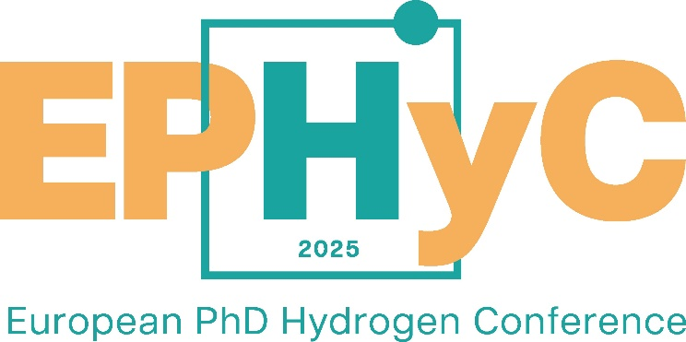

The University of Trieste is pleased to announce that, in collaboration with Hydrogen Europe Research and with the support of the research institutions involved in the NAHV project, is organizing the European PhD Hydrogen Conference (EPHyC) 2025.

EPHyC is a conference organized by PhD students for EU-based PhD researchers working on a hydrogen-related research topic, and the event will be held in Trieste from 9 to 11 April 2025 (more info at: [www.ephycconference.com](http://www.ephycconference.com) ).

EPHyC 2025 is the second edition of the conference. The previous edition was organized in Ghent, Belgium, and it has been great successful within the student community, attracting around 170 PhD students from 19 different European countries with about 10 industry companies involved in the event sponsorship.

From company side, the conference sponsorship of EPHyC 2025 can be an opportunity to:

* develop its academic network,
* find out about top-notch research at renewed knowledge institutes all over Europe,
* increase its visibility,
* get inspired.

The sponsors benefits include:

1. Representation: two representatives each company can join the conference,
2. Visibility & Promotion: sponsorship program through social media, roll up banners and video reels,
3. Industry day: free basic booth during the industry day to showcase the company.

The regular sponsorship deal is 5000 EUR and includes all the sponsorship benefits while, the special sponsorship deals ranges between 7000 and 20000 EUR with additional visibility options.

For more info please contact: [nahv@dia.units.it](mailto:nahv@dia.units.it)